**Chapter - 1 Introduction**

**1.1) Background**

**1.2) Objectives**

**1.3) Purpose**

**1.4) Scope**

**1.5) Applicability**

**Introduction to the Project**

Welcome to our presentation on Cinema Ticket Booking Systems.  
This system is a seat and ticket reservation system allowing booking in a few easy steps. Users can search for a movie in a given city, process online payments and book it. This platform provides details such as what time a movie will be played, what seats are available, movie preview, upcoming movies and so much more

**1.1 Background of Project**

* The traditional method of booking tickets involved standing in long queues at box offices.
* Over time, online booking systems have transformed the way people access entertainment.
* With the rise of the internet and mobile apps, users now demand convenience and speed in ticket booking.
* Our system provides this facility to people entertainment.

**1.2 Objectives of Project**

* To automate the ticket booking process using PHP and MySQL.
* To provide real-time updates on seat availability and schedules.
* To ensure secure and seamless payment integrations.
* To offer an admin-friendly interface for cinema management.

**1.3 Purpose of Project**

* To make booking movie tickets easy and convenient for users.
* To replace traditional manual processes with an automated solution.
* Enhance the movie-ticket booking experience with a scalable and secure system.

**1.4 Scope of Project**

* User Functionality: Allowing users to browse movies, view showtimes, select seats, and book tickets online.
* Admin Functionality: Enabling cinema administrators to manage schedules, ticket availability, and pricing.
* Payment Integration: Supporting secure online payments via multiple methods.
* Accessibility: Ensuring 24/7 access via web or mobile platforms for a hassle-free experience

**1.5 Applicability of Project**

* Cinema Chains: Centralized ticket booking for single theaters across locations.
* Web Platforms: Online ticket booking through dedicated websites.

**Chapter - 2 Requirements and Specification**

**2.1) Problem Definition**

**2.2) Requirement Specification**

**2.3) Hardware and Software Specification**

**2.3.1) Hardware Requirements**

**2.3.2) Software Requirements**

**2.4) Planning and Scheduling**

**2.4.1) Function of Project Planning**

**2.4.2) Process of Scheduling**

**2.4.3) Scheduling Chart**

**2.1 Problem Definition**

**Problem Definition:**

* The traditional method of booking movie tickets requires physical presence at the ticket counter, which is time-consuming and inconvenient.
* This project aims to develop an online movie ticket booking system that allows users to book tickets for movies from anywhere, check movie schedules, select seats, and make payments online.

**2.2 Requirement Specification**

* **Functional Requirement**
* User Registration & Login
* Movie Listings
* Ticket Booking
* Payment Integration
* Booking Confirmation
* Admin Panel
* **Non-functional Requirement:**
* Scalability
* Security
* Performance
* Availability

**2.3 Hardware and Software Specification**

**2.3.1) Hardware Requirements**

|  |  |
| --- | --- |
| Server | Processor: At least a quad-core CPU with a high speed (e.g., Intel Xeon or AMD clock EPYC) |
| Ram | Min 2 GB, 4GB, 8GB |
| Client Devices | Desktop, laptop, or mobile device with an internet connection |

**Figure 2.3.1**

**2.3.2) Software Requirements**

|  |  |
| --- | --- |
| Operating System | Windows/Linux/MacOS |
| Database | PHP/MySQL |
| Backend | PHP |
| Frontend | CSS, Bootstrap, Html, JavaScript |
| Package | Php vesion 8.3. |

**Figure 2.3.2**

**2.4 Planning and Scheduling**

|  |  |  |  |  |  |
| --- | --- | --- | --- | --- | --- |
| Duration  Activity | 12 Dec 2024  To  26 Dec 2024 | 27 Dec 24 To  18 Jan 25 | 19 Jan 25  To  11 Feb 25 | 11 Feb 25  To  05 march 25 | 6 Mar 25 To  12 Mar 25 |
| Chapter - 1  (Introduction) |  |  |  |  |  |
| Chapter - 2  (Requirement Specification) |  |  |  |  |  |
| Chapter - 3  (System Design) |  |  |  |  |  |
| Chapter - 4  (Testing and Implementation) |  |  |  |  |  |
| Chapter - 5 (Conclusion,Limitation,Future Scope and Bibliography) |  |  |  |  |  |

**Figure 2.4.1**

**Chapter - 3 System Design**

**3.1) Overall System Design Using Designing Tools**

**3.1.1) Data flow diagram**

**3.1.2) Use-case diagram**

**3.1.3) Activity diagram**

**3.1.4) Sequence diagram**

**3.1.5) Entity-relationship diagram**

**3.2) Data dictionary**

**3.3) Input / Output Design**

**3.1 Overall System Design Using Designing Tools**

* **UML Diagrams**
* **Data Flow Diagram**
* **Use Case Diagram**
* **Activity Diagram**
* **Sequence Diagram**
* **Entity Relationship Diagram**

**UML Diagrams**

**3.1.1) Data Flow Diagram**

* A data flow diagram (DFD) maps out the flow of information for any process or system. It uses defined symbols like rectangles, circles and arrows, plus short text labels, to show data inputs, outputs, storage points and the routes between each destination.
* Data flowcharts can range from simple, even hand-drawn process overviews, to in-depth, multi-level DFDs that dig progressively deeper into how the data is handled. They can be used to analyze an existing system or model a new one.
* Using any convention’s DFD rules or guidelines, the symbols depict the four components of data flow diagrams.

|  |  |
| --- | --- |
| Notation | Description |
| * External Entity | * An outside system that sends or receives data, communicating with the system being diagrammed. They are the sources and destinations of information entering or leaving the system. |
| * Process | * Any process that changes the data, producing an output. It might perform computations, or sort data based on logic, or direct the data flow based on business rules. A short label is used to describe the process, such as “Submit payment.” |
| * Data Store | * Files or repositories that hold information for later use, such as a database table or a membership form. Each data store receives a simple label, such as “Orders.” |
| * Data Flow | * Data flow: the route that data takes between the external entities, processes and data stores. It portrays the interface between the other components and is shown with arrows, typically labeled with a short data name, like “Billing details. |

* **Zero Level Data Flow Diagram:**

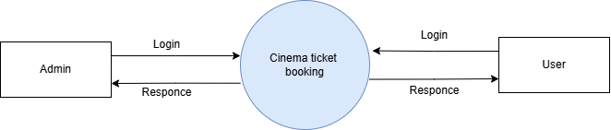

**Figure 3.1.1.1**

* **First Level DFD Admin:**

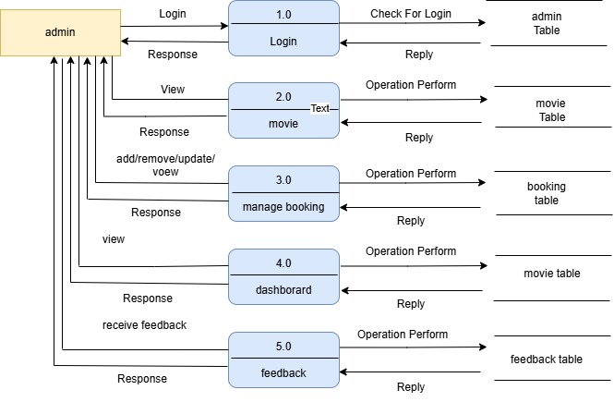

**Figure 3.1.1.2**

* **Second Level DFD:**

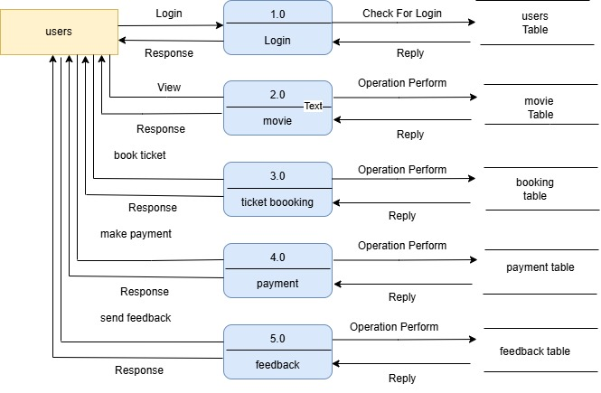

**Figure 3.1.1.3**

**UML Diagrams**

**3.1.2) Use Case Diagram:**

* A use case diagram is a dynamic or behavior diagram in UML. Use case diagrams model the functionality of a using actor and use cases. Use case is a set of actions, services, and functions that the system needs to perform. In this context, a “system” is something begins developed or operated, such as a web site. The “actors " are people or entities operating under defined roles within the system.

|  |  |
| --- | --- |
| Notation | Description |
| * Use case: | * Draw use cases using ovals. Label the ovals with verbs that represent the system's functions. |
| * Actors: | * Actor are the users of a system. An actor represents a role played by a user or external system that interacts with the system being modeled. |
| * Relationship : | * Relationship between actor and a use case with a simple line. |

**Use case Diagram: User**

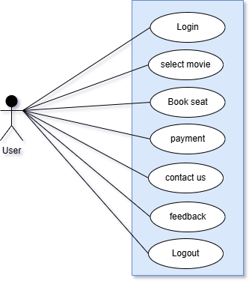

**Figure 3.1.2.1**

**Use case Diagram: Admin**

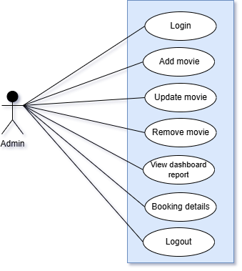

**Figure 3.1.2.2**

**UML Diagrams**

**3.1.3) Activity Diagram:**

* Activity Diagram describes how activities are coordinated to provide a service which can be at different levels of abstraction. Typically, an event needs to be achieved by some operations, particularly where the operation is intended to achieve a number of different things that require coordination, or how the events in a single use case relate to one another, in particular, use cases where activities may overlap and require coordination.

|  |  |
| --- | --- |
| Notation | Description |
| * Start point: | * Small filled circle followed by an arrow represents the initial action state or the start point for any activity diagram. |
| * Action state: | * An action state represents the non - interruptible action of objects. Rectangle with rounded corners. |
| * Action flow: | * Action flows, also called edges and paths, illustrate the transitions from one action state to another. |
| * Decision symbol: | * A diamond represents a decision with alternate paths. When an activity requires a decision prior to moving on to the text activity, add a diamond between the two activities. |

**Activity Diagram: Admin**

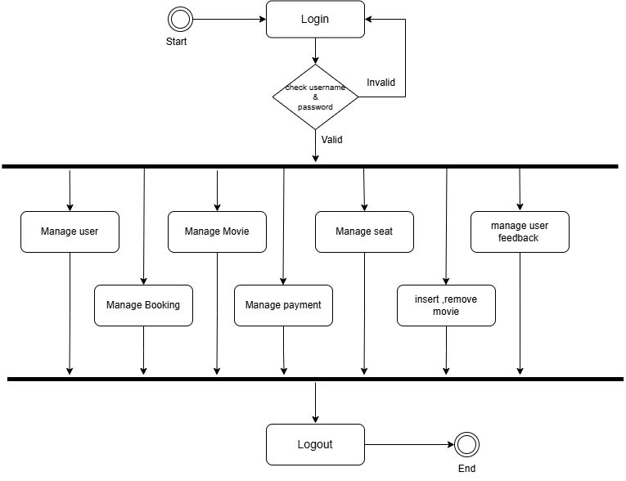

**Figure 3.1.3.1**

**Activity Diagram: user**

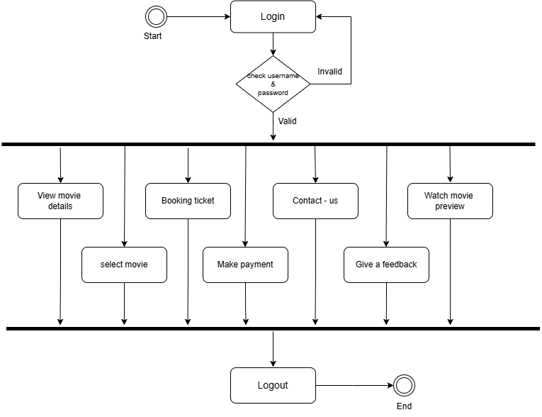

**Figure 3.1.3.2**

**UML Diagrams**

**3.1.4) Sequence Diagram:**

* The interaction that takes place in a collaboration that either realizes a use case or an operation.
* High - level interaction between user of the system and the system, between the system and other systems, or between subsystems.

|  |  |
| --- | --- |
| Notation | Description |
| * Call message: | * Message defines a particular communication between lifelines of an interaction. |
| * Return message: | * Return message is a kind of message that represents the pass of information back to the caller of a corresponded former message. |
| * Object : | * Depicted with rectangle shape, object represents and instances of class of needed. |
| * Bar: | * These are used to show the start and end of concurrent in the diagram. |

**Sequence Diagram: Admin**

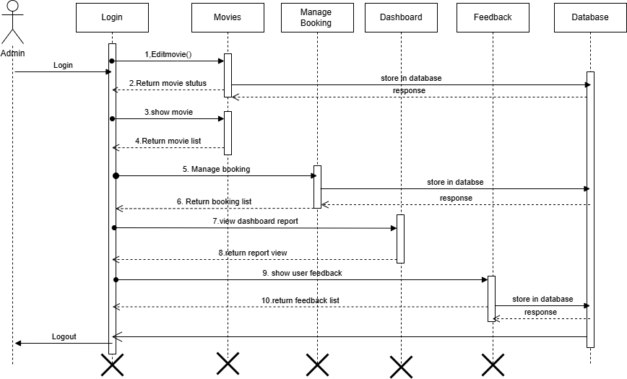

**Figure 3.1.4.1**

**Sequence Diagram: User**

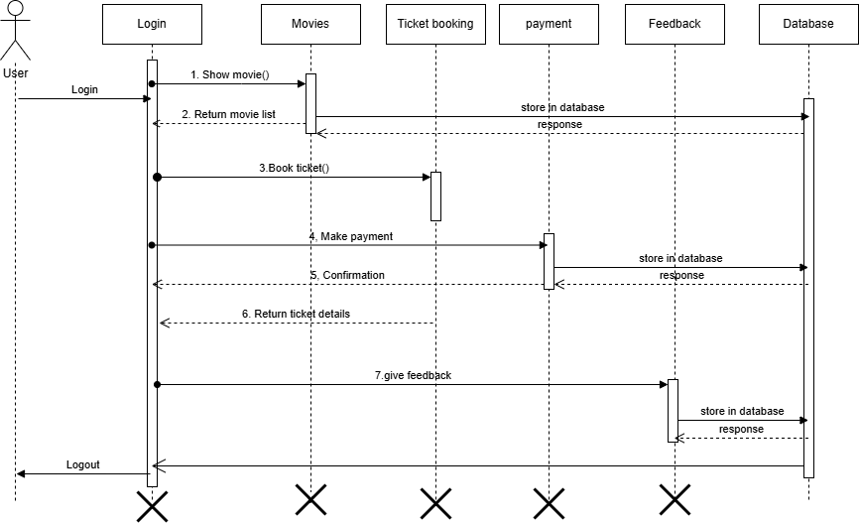

**Figure 3.1.4.2**

**UML Diagrams**

**3.1.5) Entity Relationship Diagram:**

* An entity relationship diagram (ERD) shows the relationship of entity sets stored in a database. An entity in this context is an object, a component of data. An entity set is a collection of similar entities. These entities can have attributes that define its properties.
* By defining the entities, their attributes, and showing the relationship between them, an ER diagram illustrates the logical structure of databases.

|  |  |
| --- | --- |
| Notation | Description |
| * Entity | * Single rectangle is used for representing a strong entity set. |
| * Relationship: | * Relationship exists between two strong entity sets. It is represented using a diamond symbol. |
| * Attributes: | * Attributes are the properties which describe the entities of an entity set. |
| * Aero: | * Join parts. |

**Entity Relationship Diagram:**

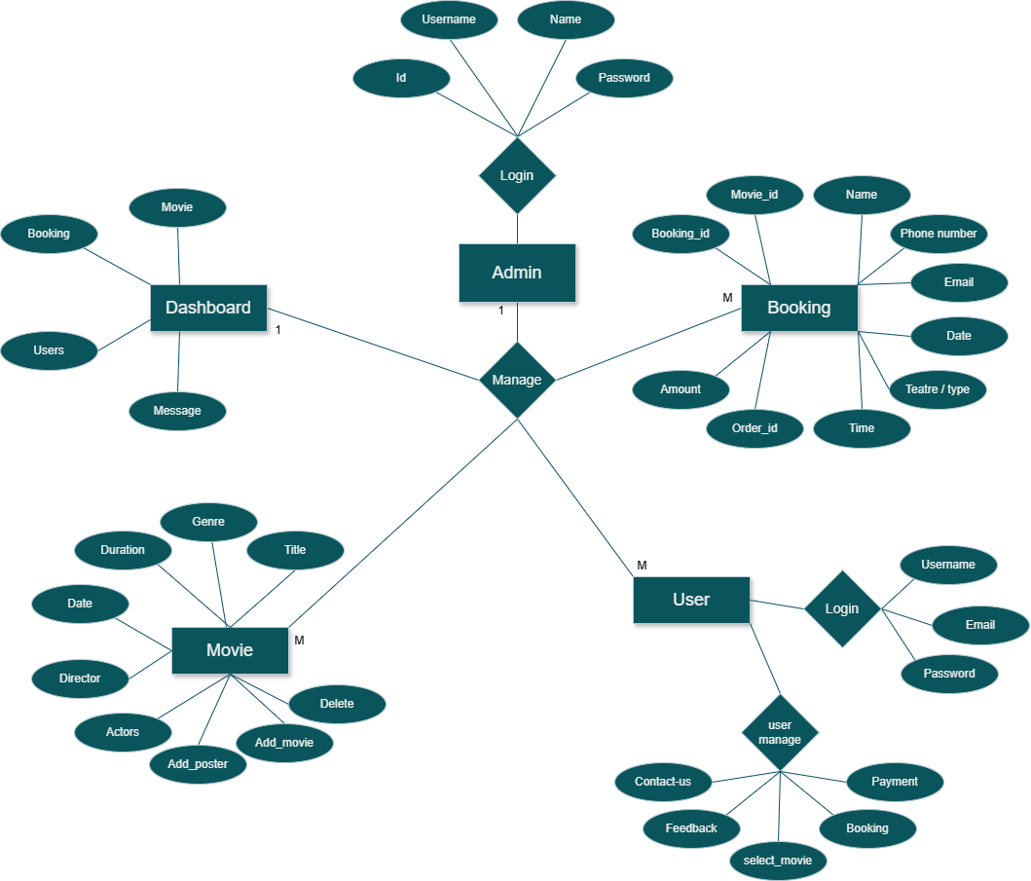

**Figure 3.1.5.1**

**3.2 Data Dictionary**

* A data dictionary is catalogue of the elements in a system. The major elements are data flows, data stores, and process. The data dictionary stores details description of these elements.

* If analysts want to know many characters are in a data item, by what other names it is referenced in the system. Or where it is used in the system, they should be able to find answers in a properly developed Data Dictionary.
* However, its contents are used during systems design as well.

**List of Table:**

|  |  |  |  |  |
| --- | --- | --- | --- | --- |
| **Field Name** | **Data Type** | **Size** | **Constraint** | **Key** |
| **Booking Id** | **int** | **11** | **Not Null** | **Primary key,**  **Unique key** |
| **Movie Id** | **int** | **11** | **Default Null** | **Foreign Key** |
| **Booking Theatre** | **Varchar** | **100** | **Not Null** |  |
| **Booking Type** | **Varchar** | **100** | **Default Null** |  |
| **Booking Date** | **Varchar** | **50** | **Not Null** |  |
| **Booking Time** | **Varchar** | **50** | **Not Null** |  |
| **Booking Fname** | **Varchar** | **100** | **Not Null** |  |
| **Booking Lname** | **Varchar** | **100** | **Default Null** |  |
| **BookingPhoneno.** | **Varchar** | **10** | **Not Null** |  |
| **Booking Email** | **Varchar** | **255** | **Not Null** |  |
| **Amout** | **Varchar** | **255** | **Not Null** |  |
| **Order Id** | **Varchar** | **255** | **Not Null** | **Foreign Key** |
| **Date-Time** | **datetime** |  | **Not Null Default** |  |

* **Booking Table**
* 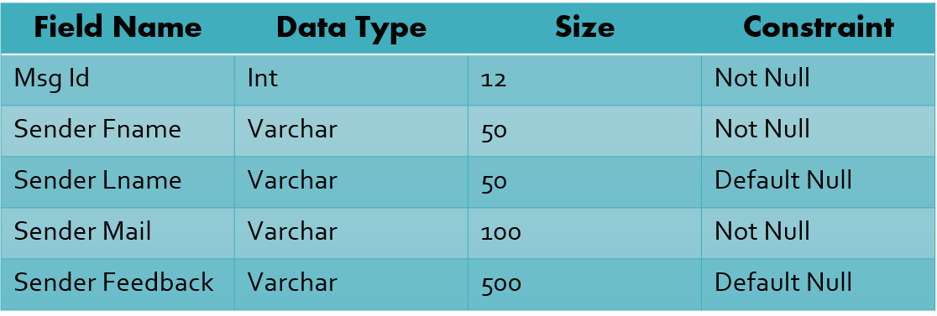**Feedback Table**

|  |  |  |  |  |
| --- | --- | --- | --- | --- |
| **Field Name** | **Data Type** | **Size** | **Constraint** | **Key** |
| **Movie Id** | **Int** | **11** | **Not Null** | **Primary key,**  **Unique key** |
| **Movie Imge** | **Varchar** | **150** | **Not Null** |  |
| **Movie Title** | **Varchar** | **100** | **Not Null** |  |
| **Movie Genre** | **Varchar** | **50** | **Not Null** |  |
| **Movie Duration** | **Int** | **11** | **Not Null** |  |
| **Movie Reldate** | **date** |  | **Not Null** |  |
| **Movie Director** | **Varchar** | **50** | **Not Null** |  |
| **Movie Actors** | **Varchar** | **150** | **Not Null** |  |
| **Main Hall** | **Int** | **11** | **Not Null** |  |
| **Vip Hall** | **Int** | **11** | **Not Null** |  |
| **Private Hall** | **Int** | **11** | **Not Null** |  |

* **Movie Table**
* **User Table**

|  |  |  |  |
| --- | --- | --- | --- |
| **Field Name** | **Data Type** | **Size** | **Constraint** |
| **User Name** | **Varchar** | **100** | **Not Null** |
| **Email** | **Varchar** | **100** | **Not Null** |
| **Password** | **Varchar** | **100** | **Not Null** |

* **Admin Table**

|  |  |  |  |
| --- | --- | --- | --- |
| **Field Name** | **Data Type** | **Size** | **Constraint** |
| **Id** | **Int** | **11** | **Not Null** |
| **Admin Name** | **Varchar** | **80** | **Not Null** |
| **Name** | **Varchar** | **80** | **Not Null** |
| **Password** | **Varchar** | **80** | **Not Null** |

**3.3 Input / Output Design**

* **Home Page**

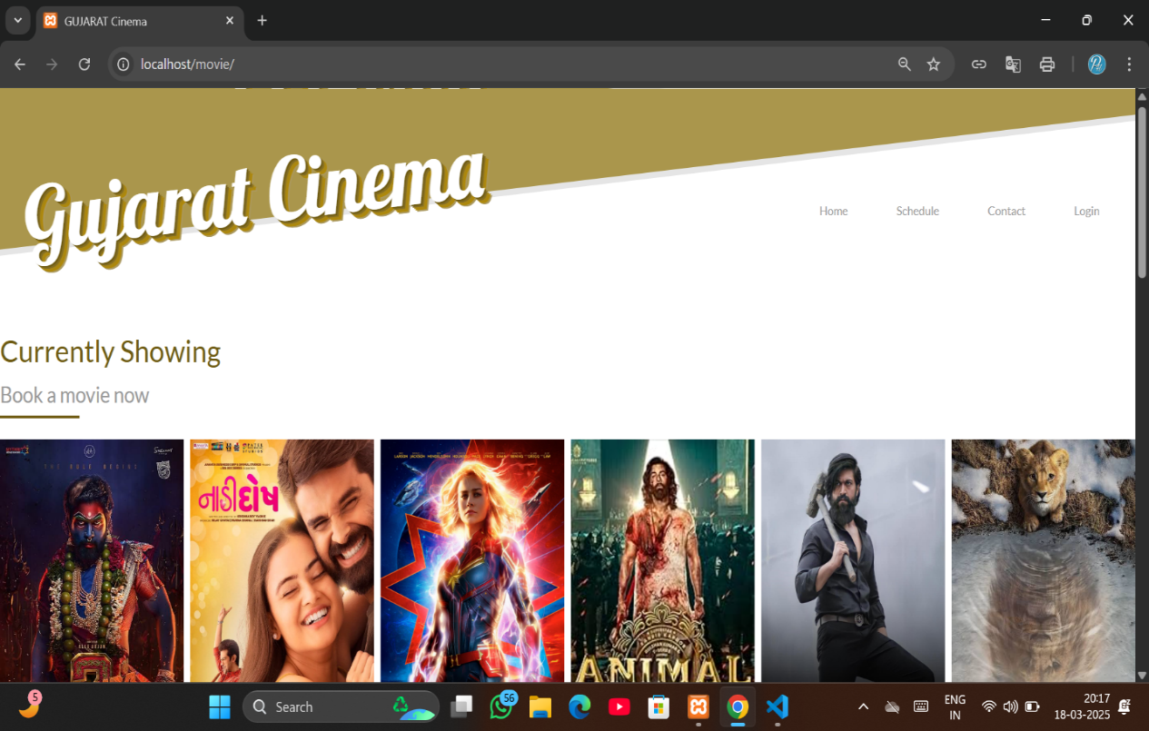

* This page is home page of cinema ticket booking
* This page provides how it works website

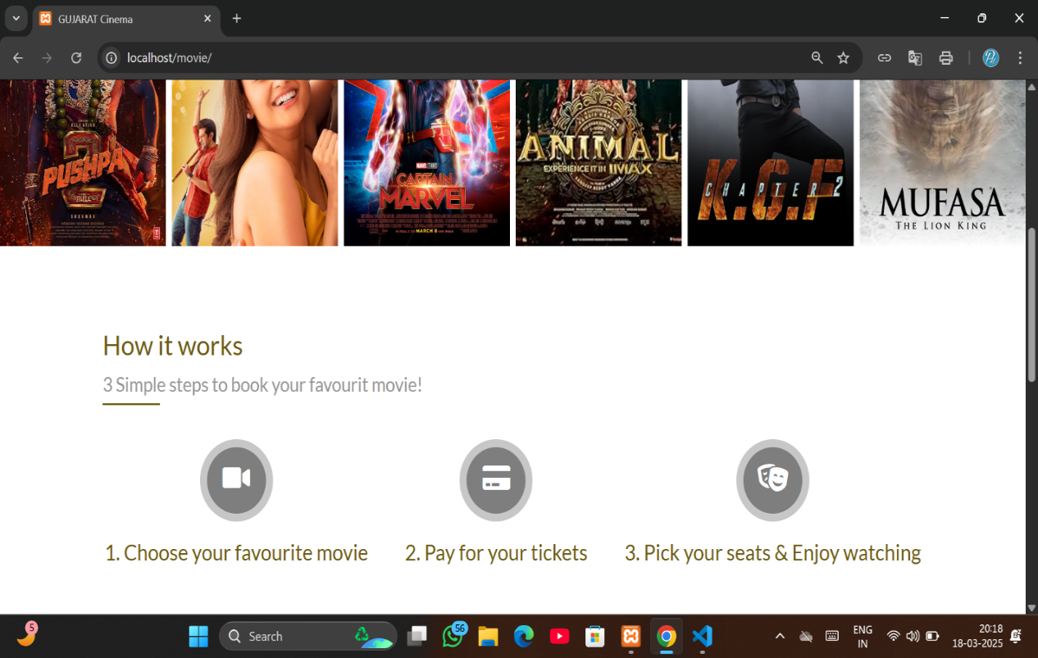

* This page provides trailer of movie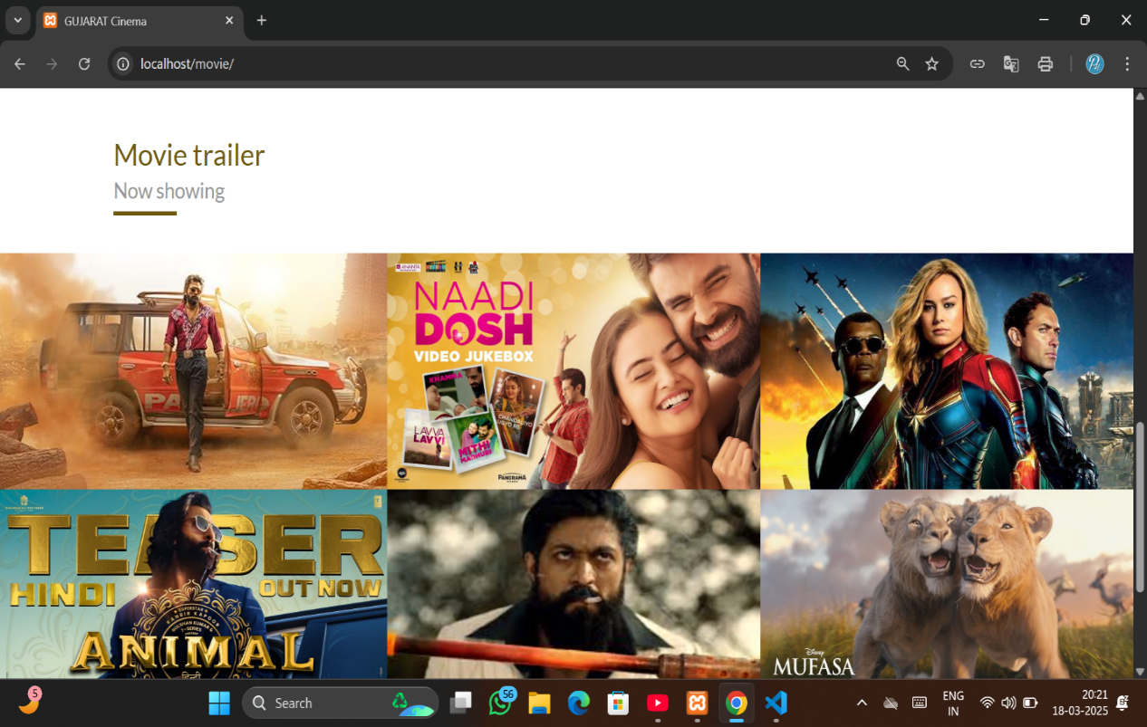
* Play the movie trailer

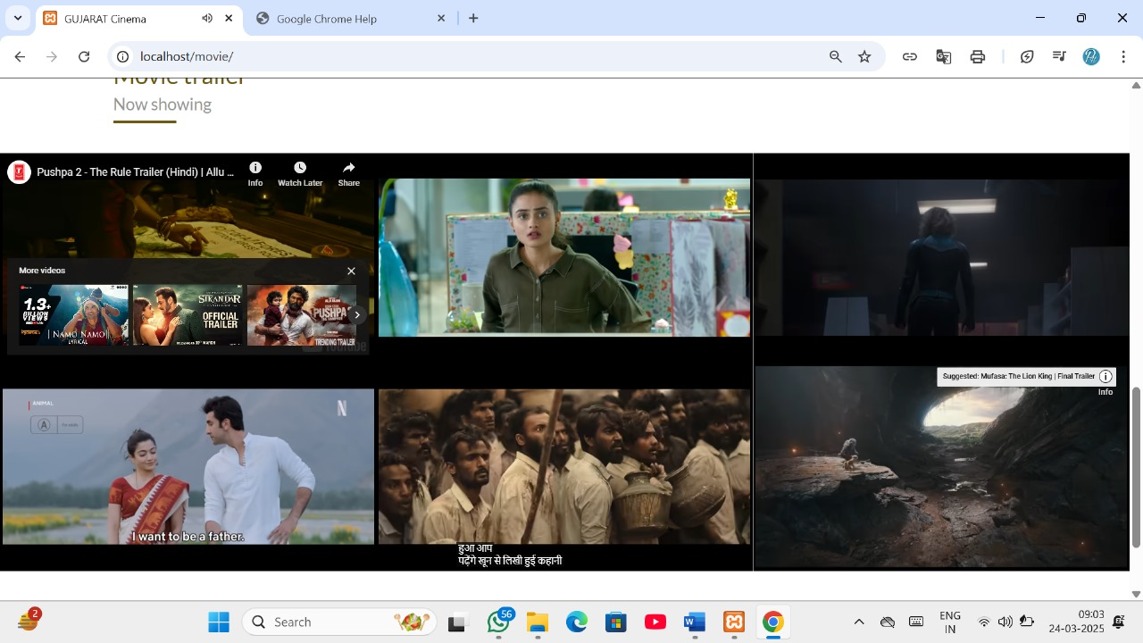

* 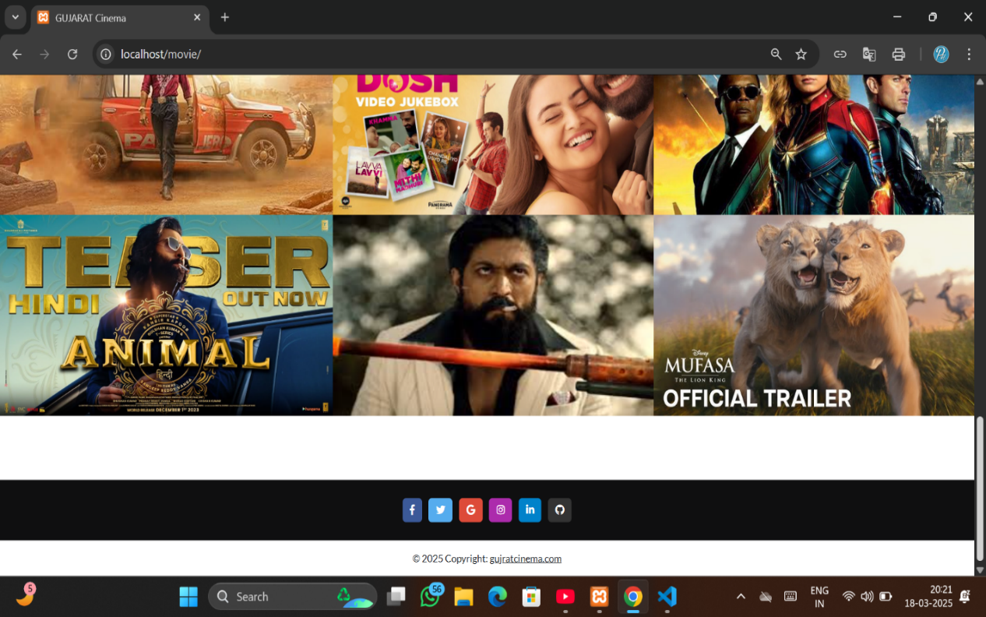**Footer page**
* This page provides footer page
* **Movie Schedule**

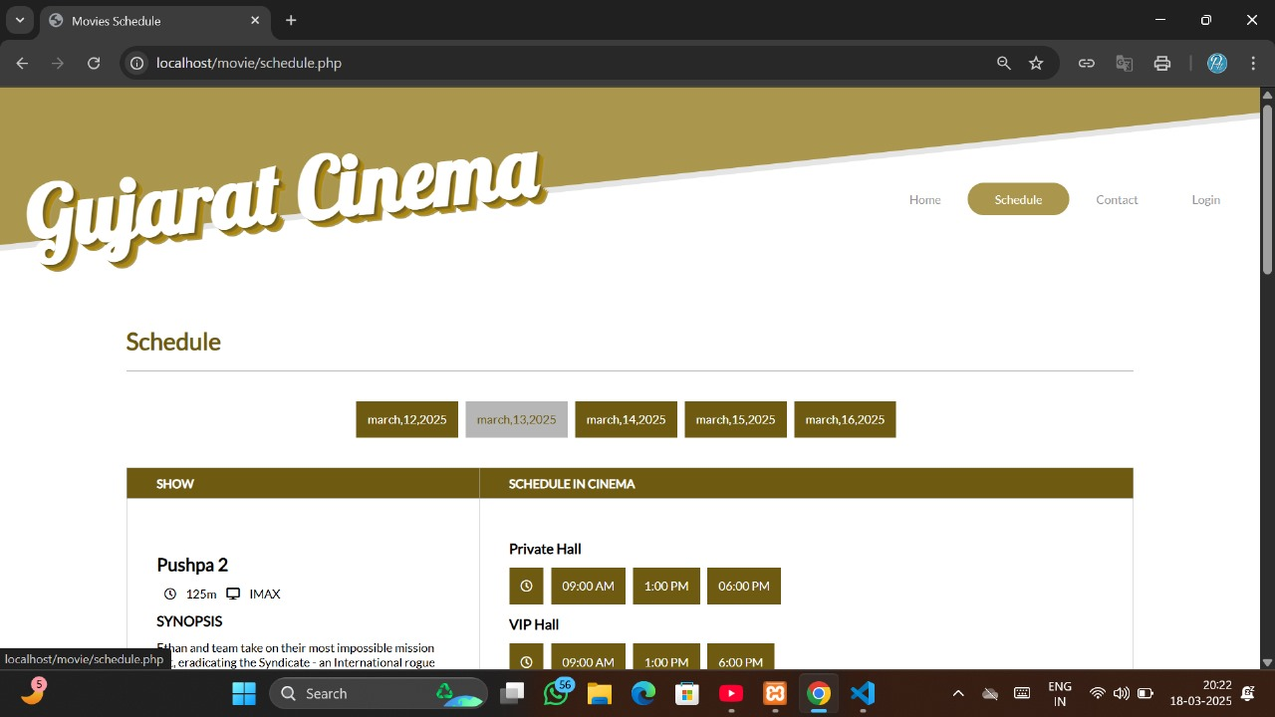

* This page provides schedure of the movie
* This page is used to show movie schedule

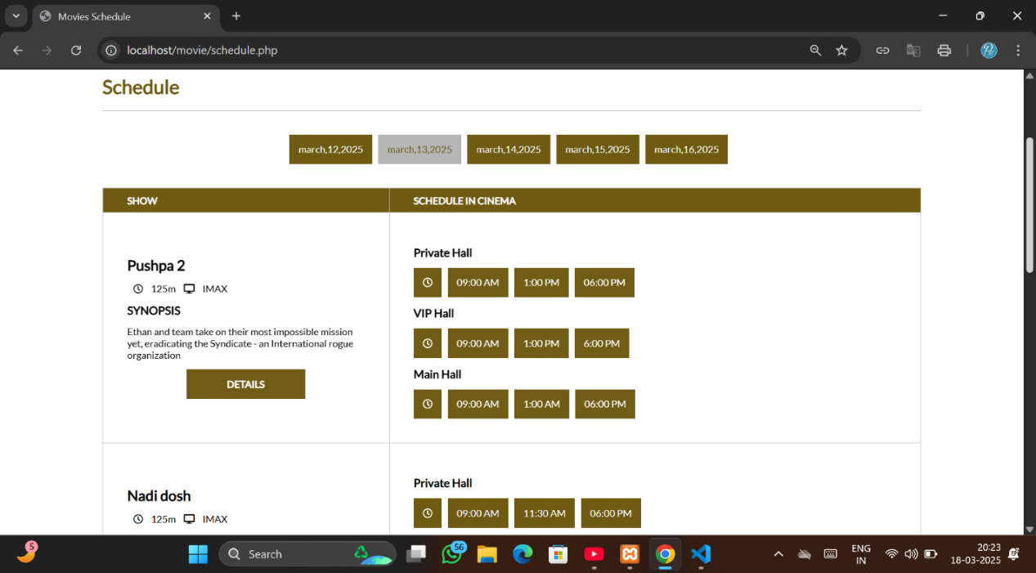

* **Feedback Page**

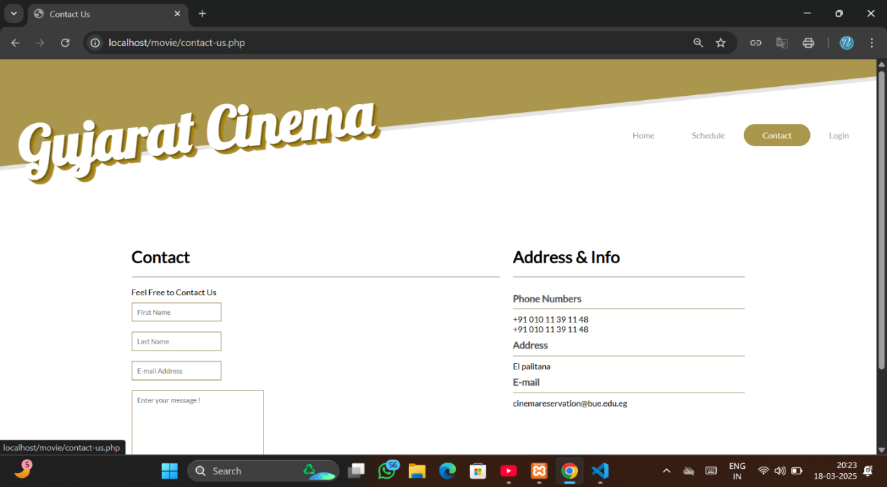

* User feedback
* Feedback Validation

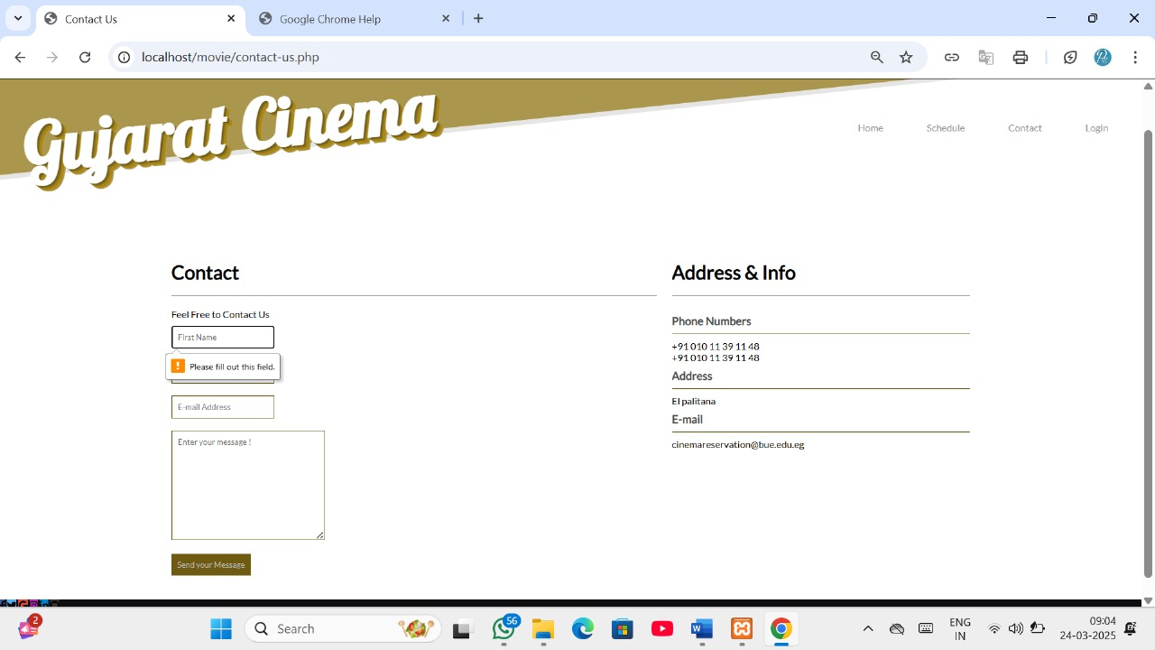

* This page is a login of user

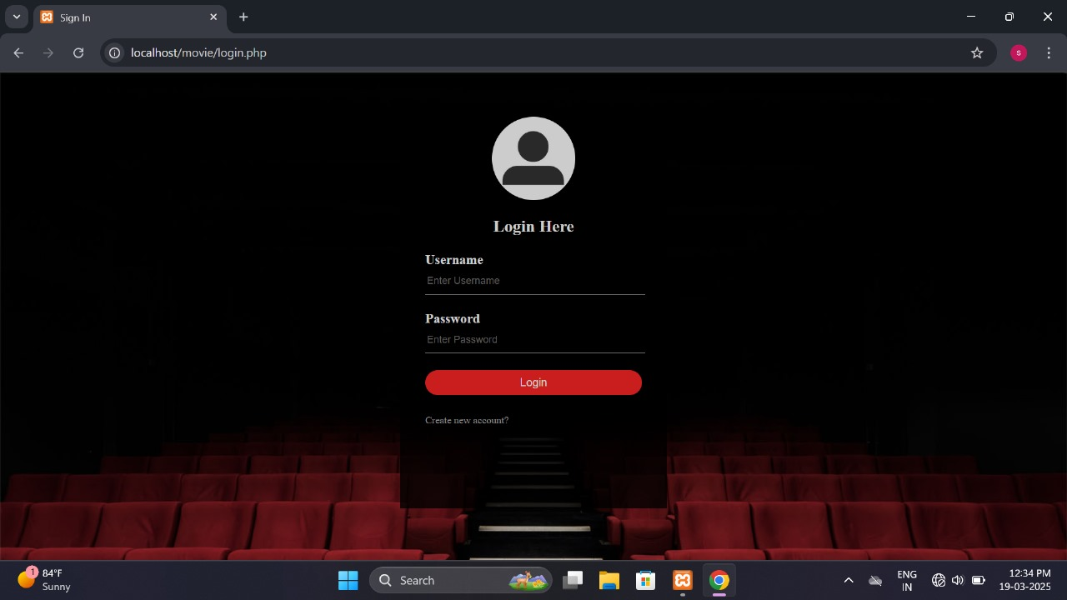

* Login Validation

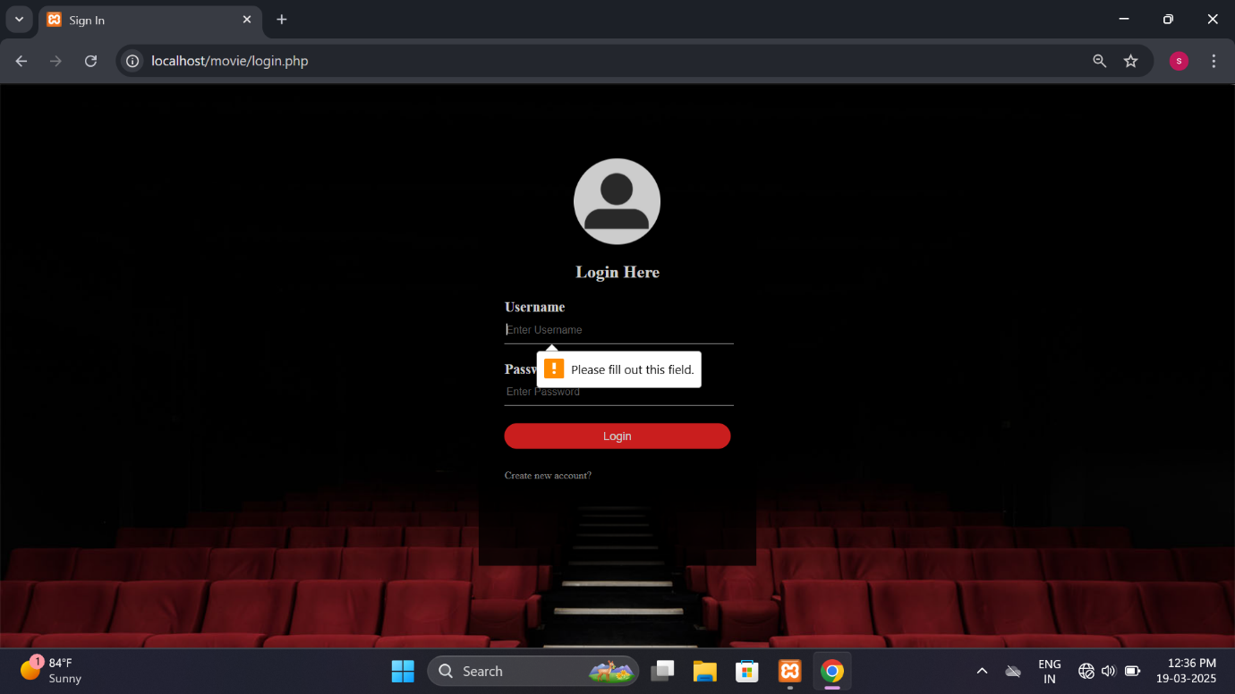

* This page is a register of user

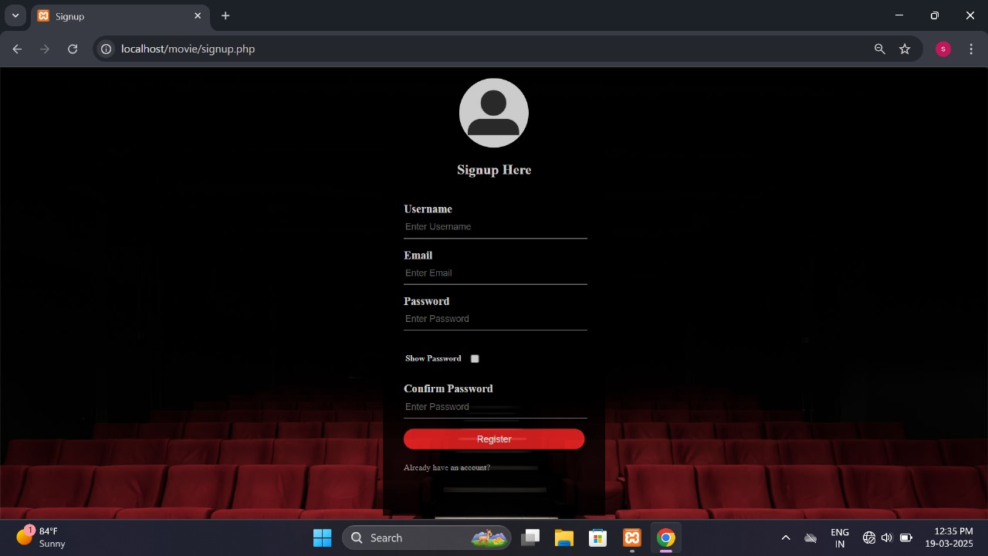

* **Sing up Validation**

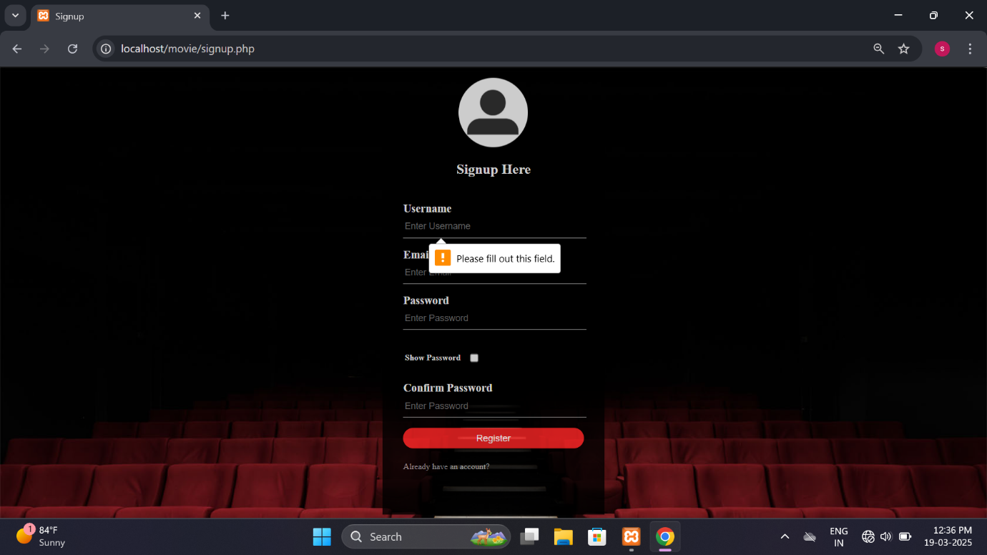

* **Booking Ticket Page**

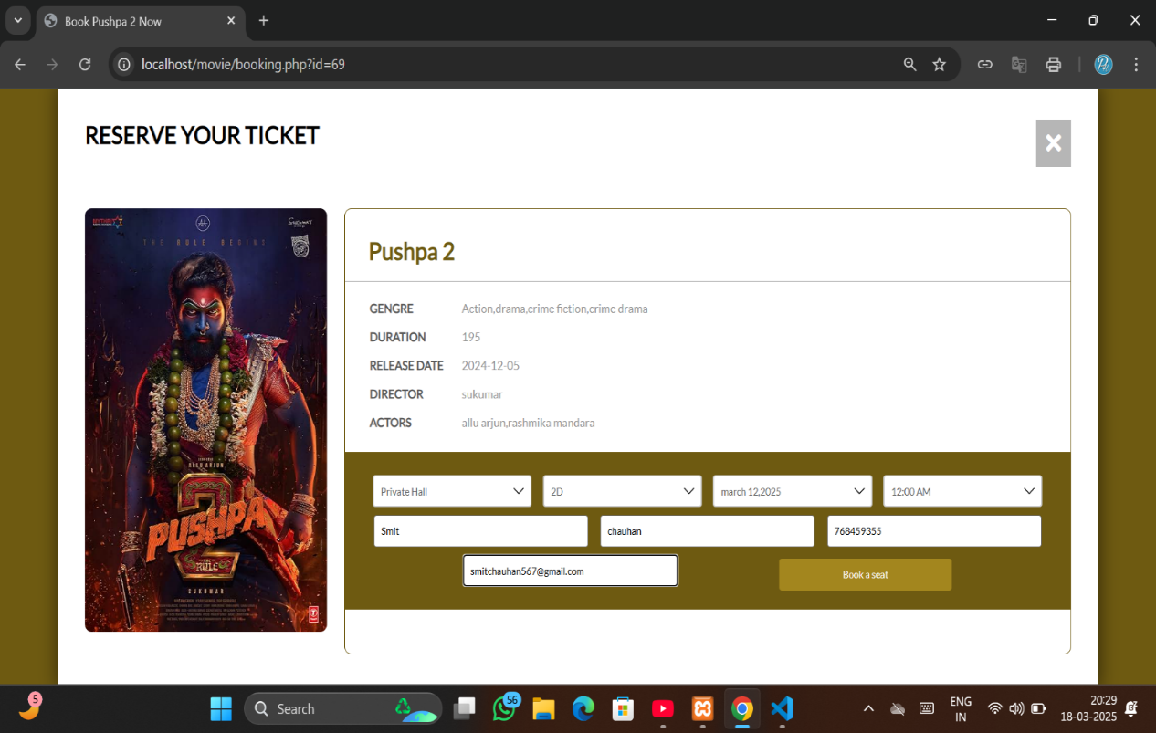

* This page used for booking process of ticket.
* Booking Validation

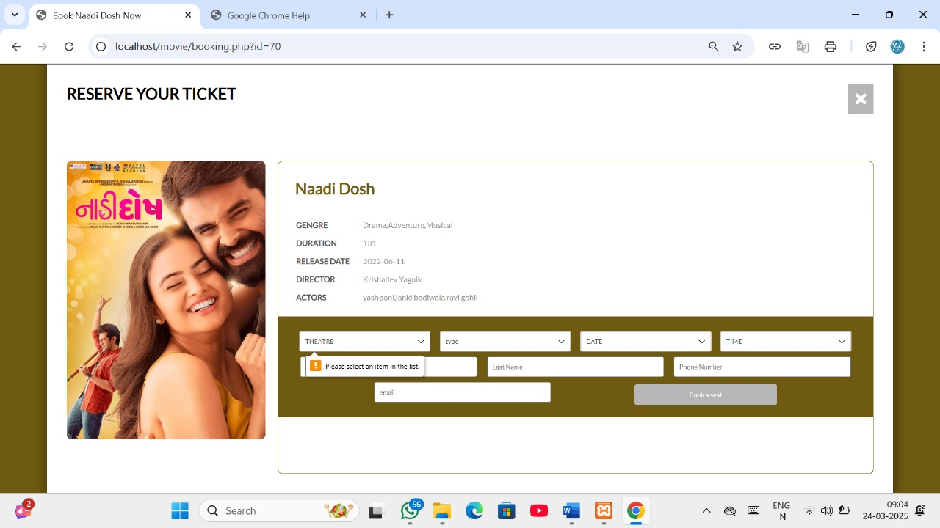

* 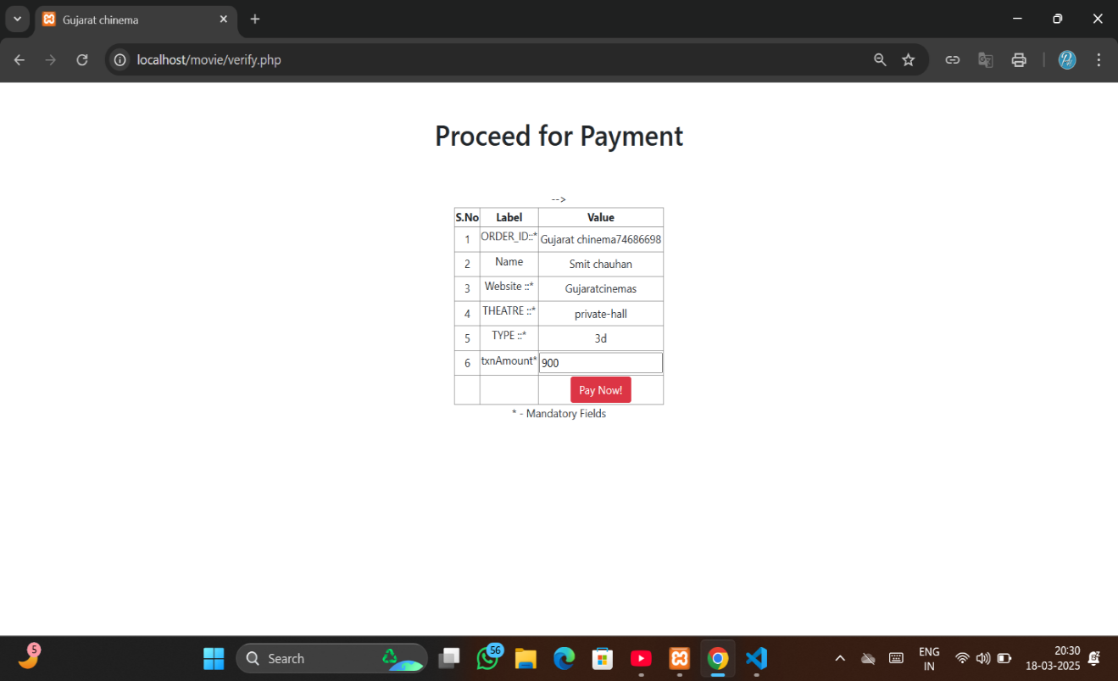Proceed for payment
* **Multiple Payment Page**

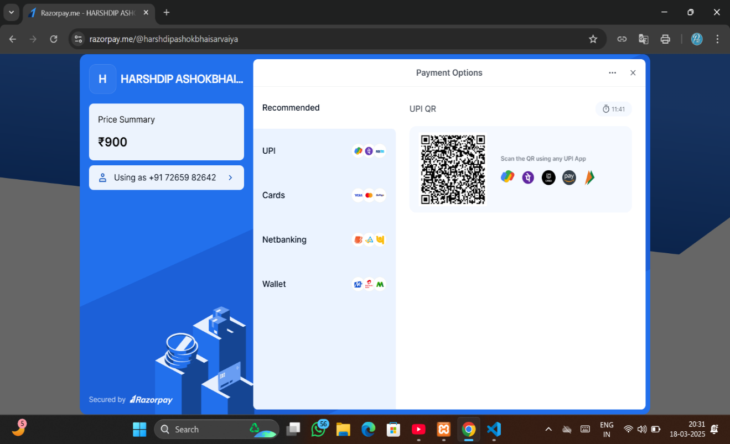

* This page used for multiple payment method
* 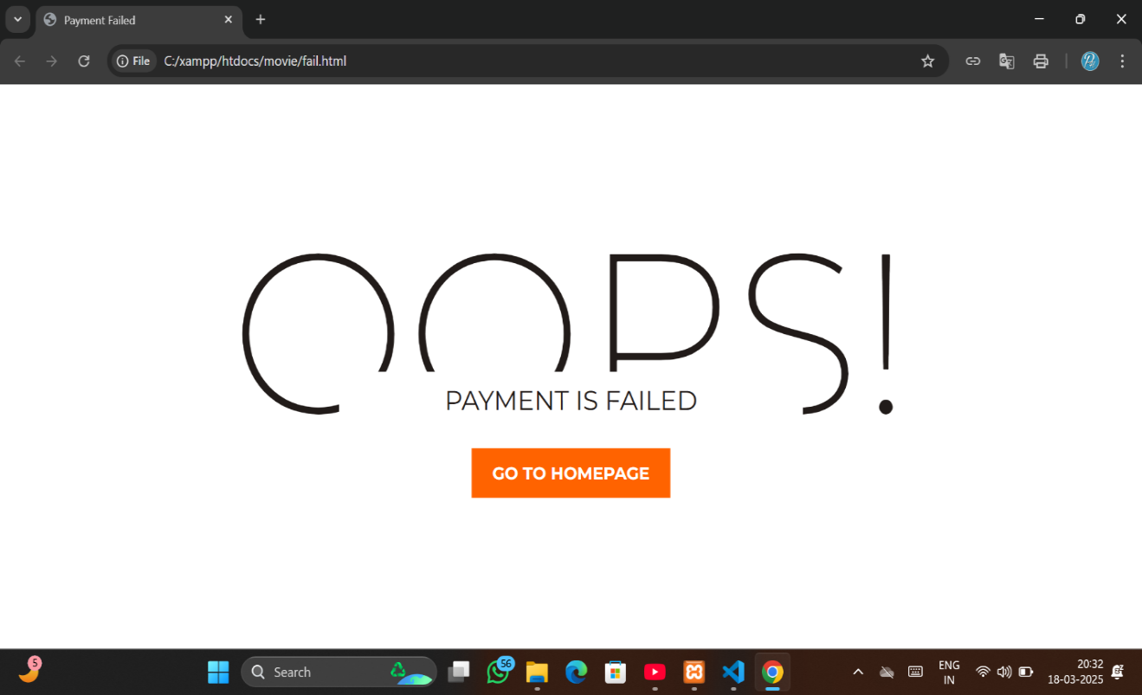**Payment fails**

* **Ticket for movie booking**

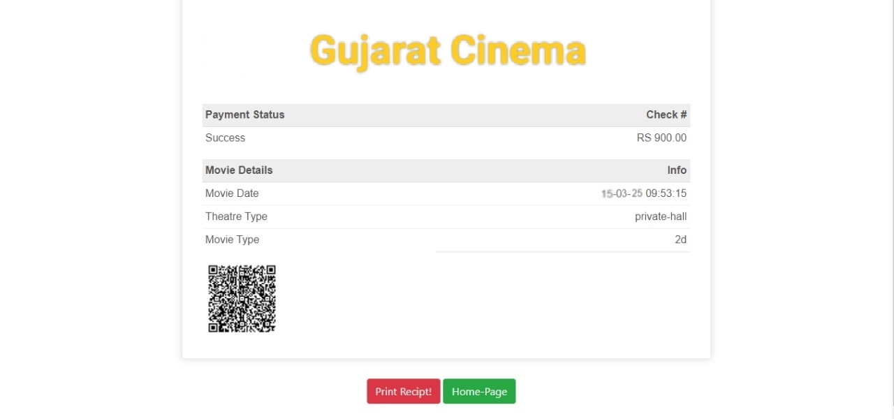

* **Admin login**
* 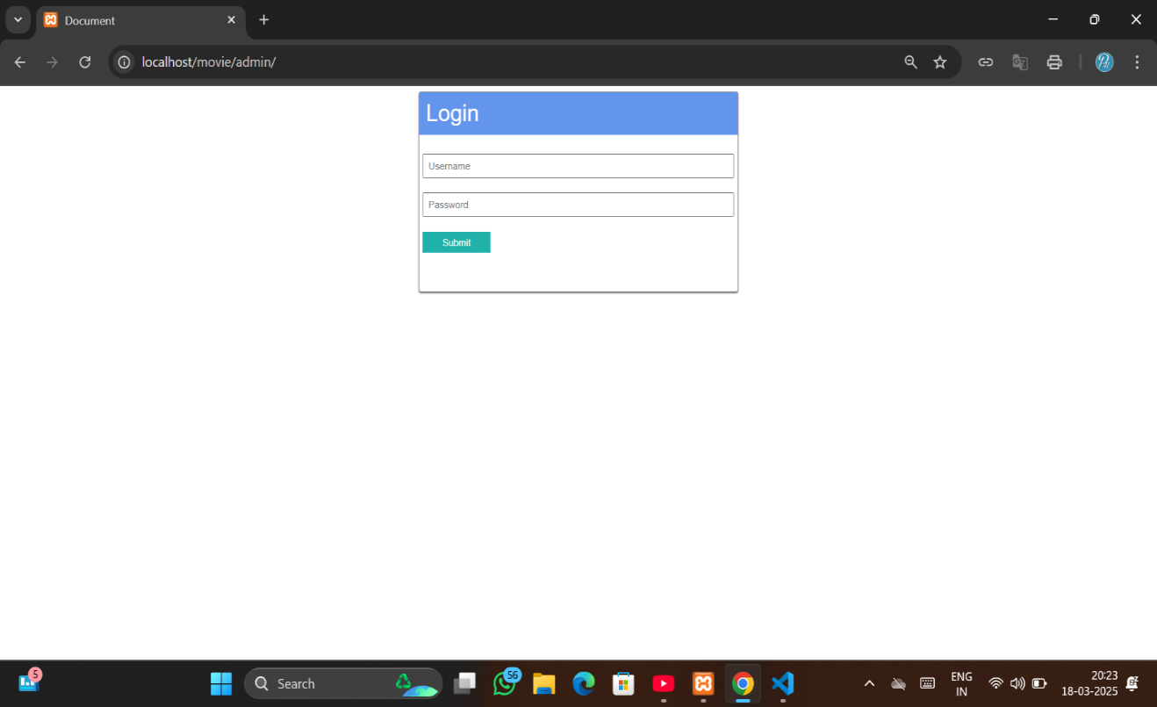This page is provided an admin login

* Admin invalid and password

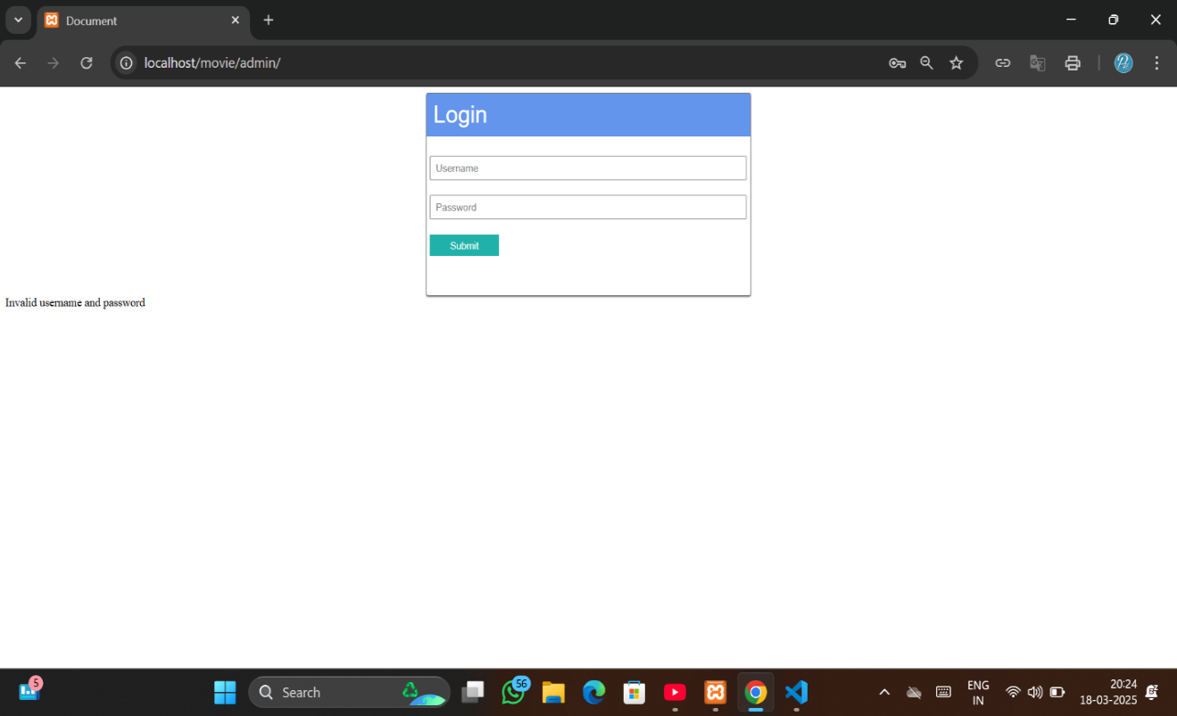

* **Admin Page**

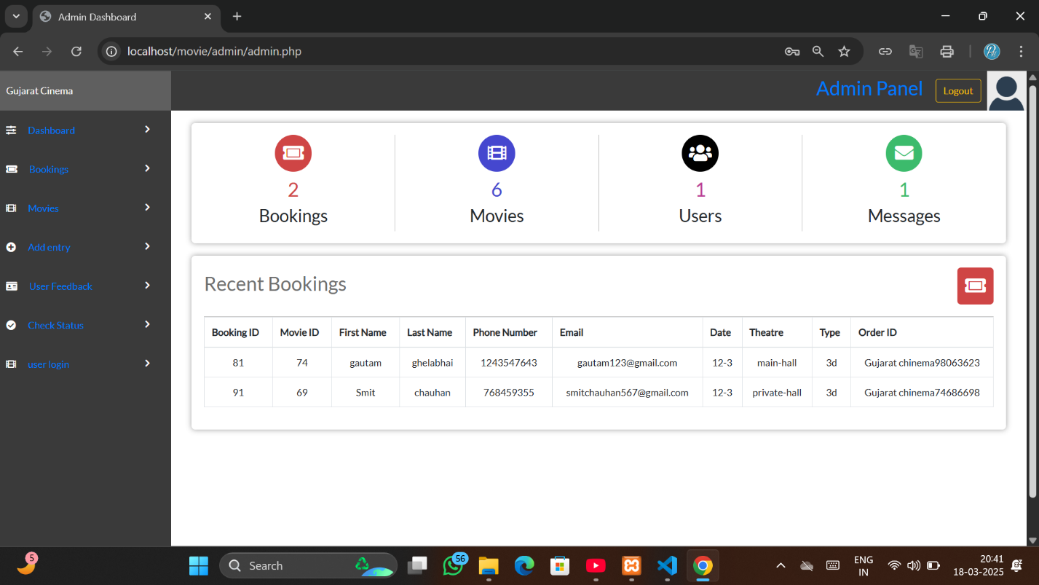

* **Booking detail**

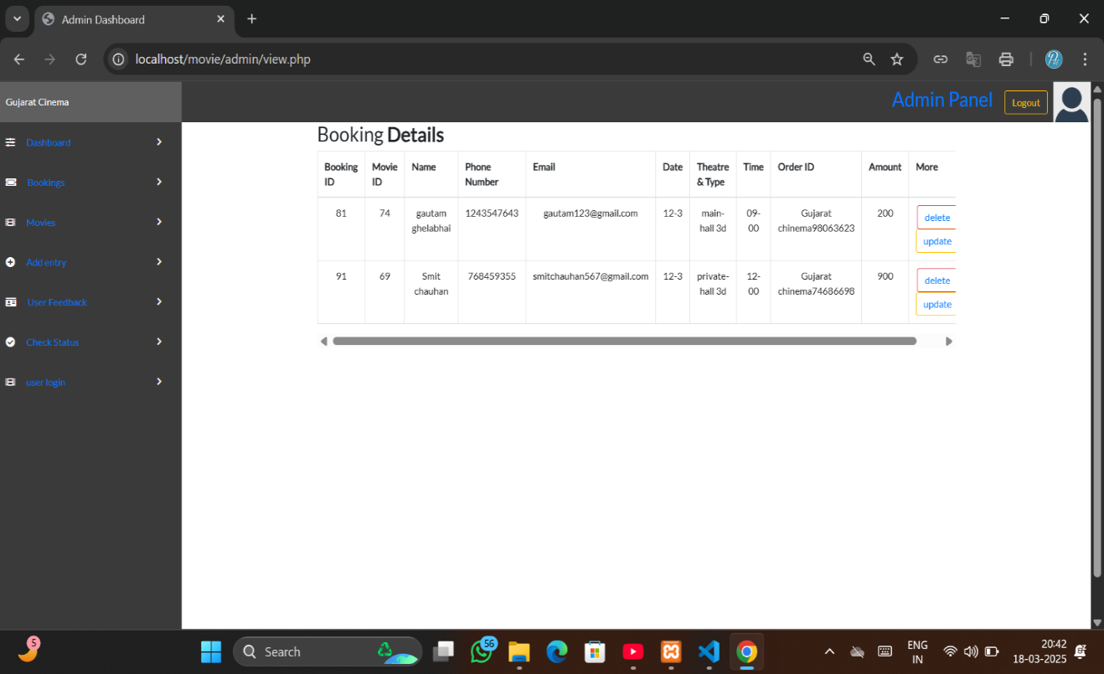

* 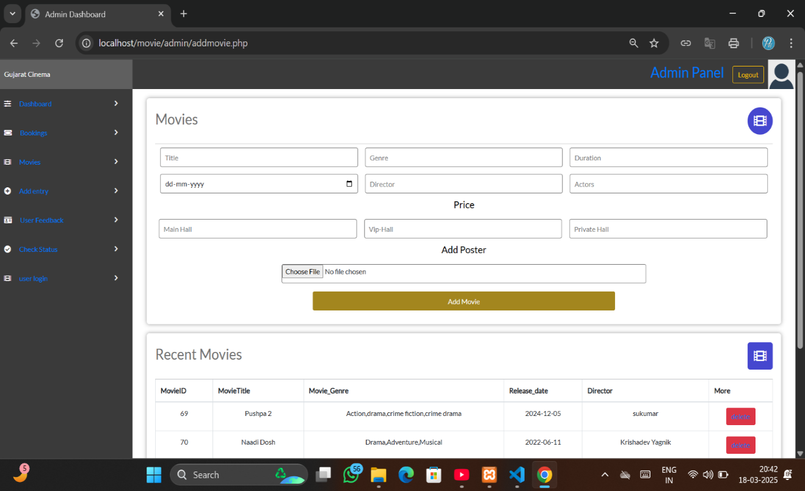**Add movie**
* **Delete Movie**

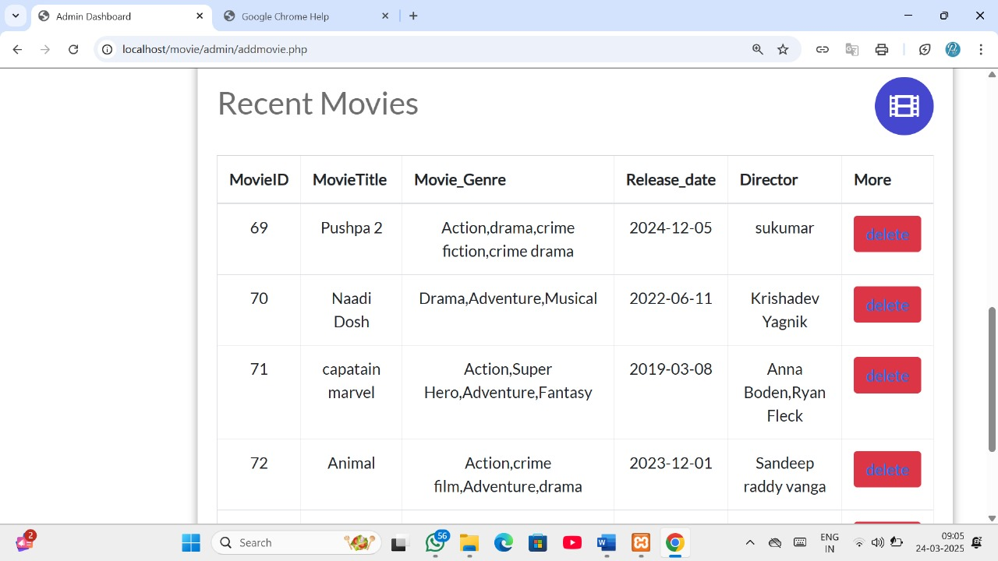

* **Add entry for booking detail**

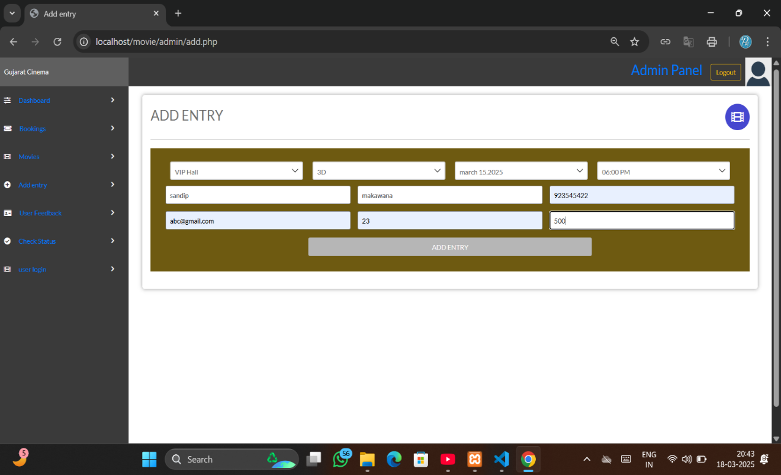

* Add entry for offline movie ticket
* **Feedback page**

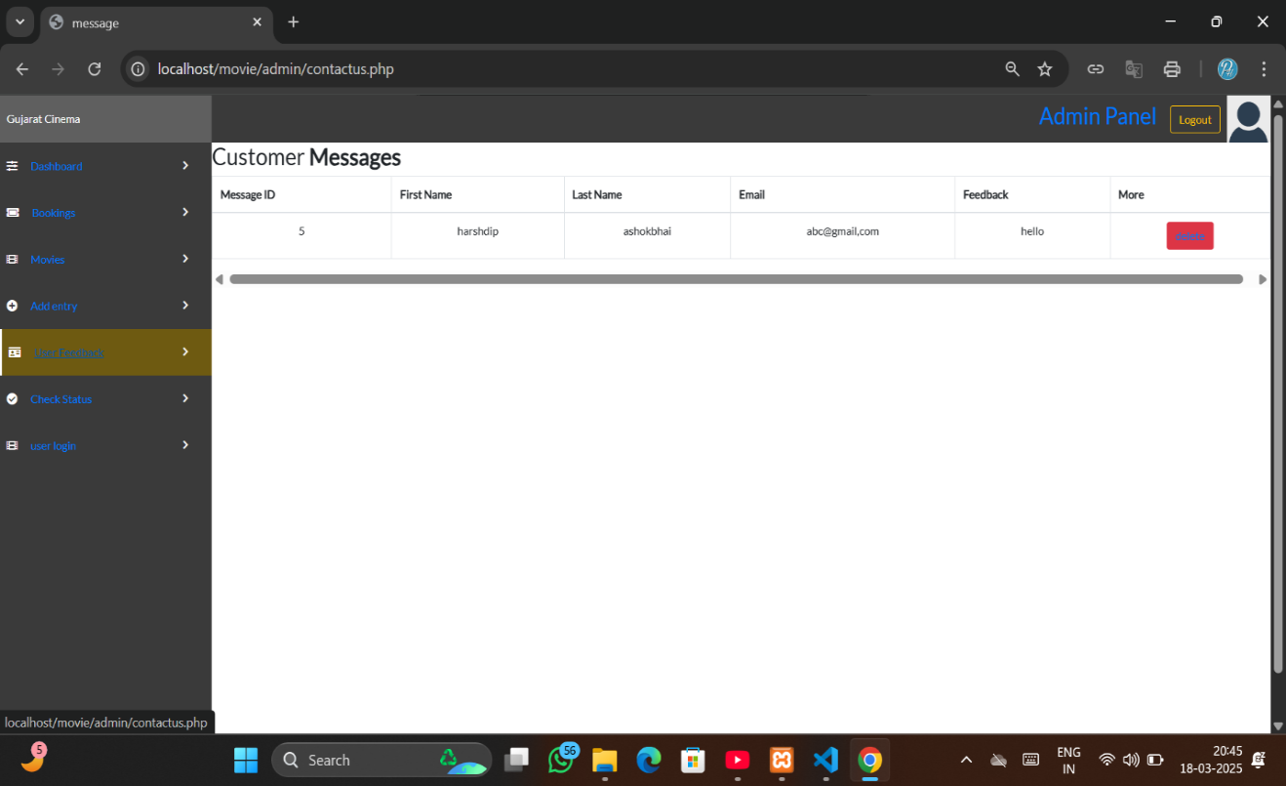

* Contact page used for user

**Chapter - 4 Testing and Implementation**

**4.1) Testing Approach**

**4.2) Test Case**

**4.3) Implementation Approach**

**4.1 Testing Approach**

* **Testing Approach**

The testing approach for the cinema ticket booking system follow include:

* **Unit Testing**: Each module, such as user authentication, seat selection, and payment processing, is tested independently.
* **System Testing**: The entire system is tested to ensure it functions as expected.
* **Black Box Testing**: Focuses on testing the functionality of the system without knowing its internal code structure.
* **White Box Testing**: Involves testing the internal logic and structure of the code to ensure proper flow and functionality

1. **Top-Down Testing:**

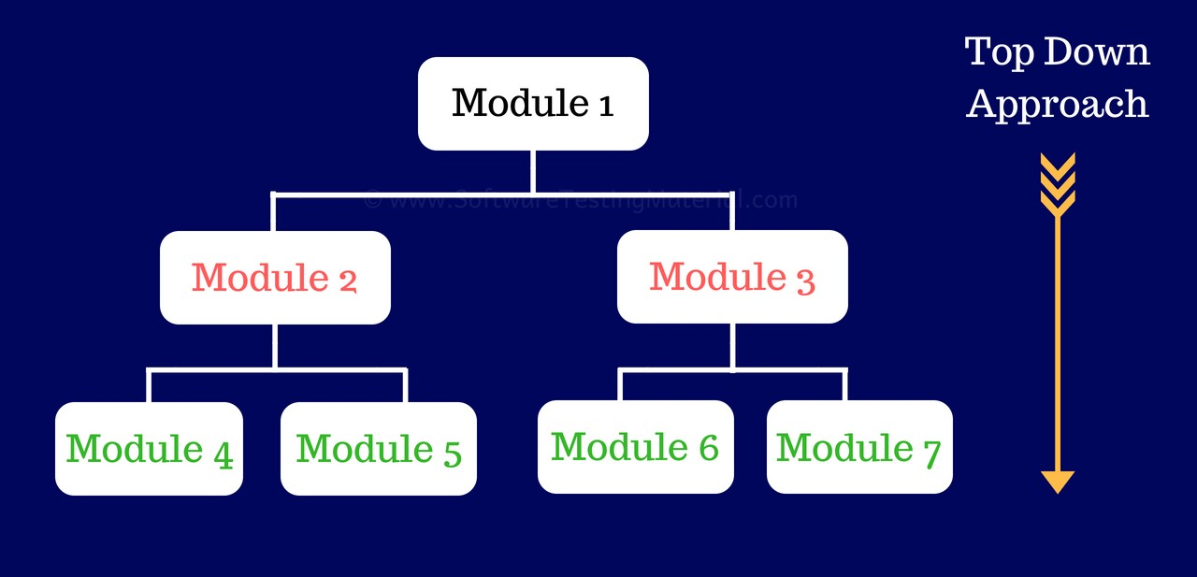

**Figure 4.1.1**

1. **Bottom-Up Testing:**

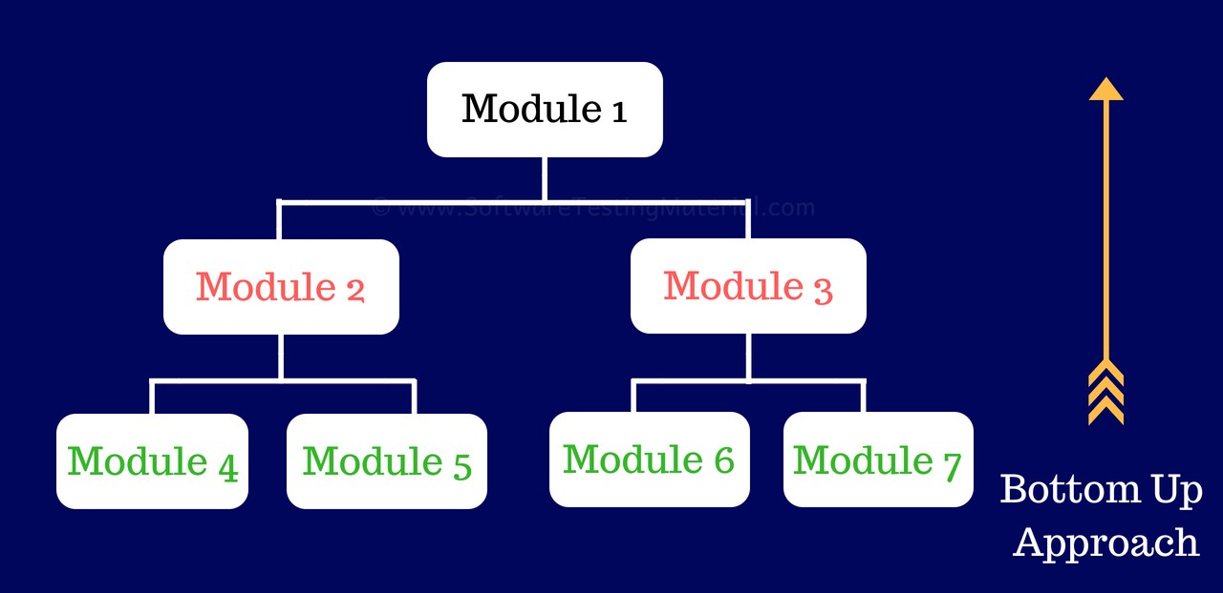

**Figure 4.1.2**

**Type of Testing:**

**1. Black Box Testing:**

* Black box testing, also known as Behavioral testing, is a software method in which the internal design/implementation of the item being tested is not known to the later.
* The technique of testing without having any knowledge of the interior workings of the applications is called black box testing. The tester is oblivious to the system architecture and does not have access to the source code. Typically, while performing a black box test, a tester will interact with the system’s user interface by providing inputs and examining outputs without knowing how and where the inputs are worked upon.

**Advantage of Black-Box Testing:**

* It becomes very easy to find out which type of data can help testing the application effectively.
* It helps in optimizing the code.
* Extra lines of code can be removed which can be bring in hidden effects.
* Due to the tester’s knowledge about the code maximum coverage attained during testing scenario writing.

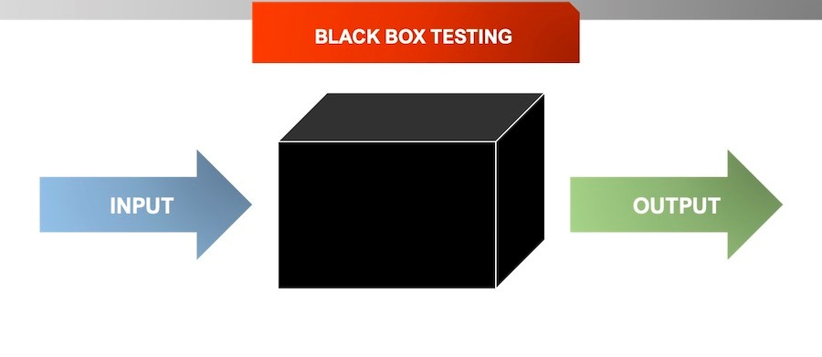

**Figure 4.1.3**

**2. White Box Testing**

* White box testing is a software testing method in which the internal structure /design / implementation of the item being tested is known to the tester.
* White box testing is the detailed investigation of internal logic and structure of the code.
* White box testing is also called glass testing or open box testing. In order to perform white box testing on an application, a tester needs to know the internal workings of the code.
* The tester needs to have a look inside the source code and find out which unit/chunk of the code is behaving inappropriately.
* White box testing techniques:
* Statement Coverage.
* Branch Coverage.
* Path Coverage.
* **Advantage of White-Box Testing:**
* Forces test developer to reason carefully about implementation.
* Reveals errors in “hidden” code.
* Spots the dead code or other issues with respect to best programming practices.

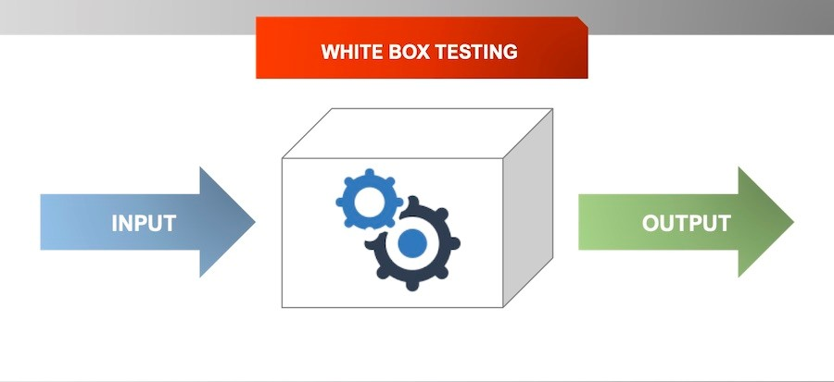**Figure 4.1.4**

**3. Grey Box Testing:**

* Grey Box testing is testing technique performed with limited information about the internal functionality of the system. Grey Box testers have access to the detailed design documents along with information about requirements.
* Grey Box tests are generated based on the state-based models, UML Diagrams or architecture diagrams of the target system.

**Grey-box testing Techniques:**

* Regression testing
* Pattern Testing
* Orthogonal array testing
* Matrix testing

**Advantages:**

* Grey-box testing provides combined benefits of both white-box and black-box testing
* It is based on functional specification, UML Diagrams, Database Diagrams or architectural view
* Grey-box tester handles can design complex test scenario more intelligently
* The added advantage of grey-box testing is that it maintains the boundary between independent testers and developers.

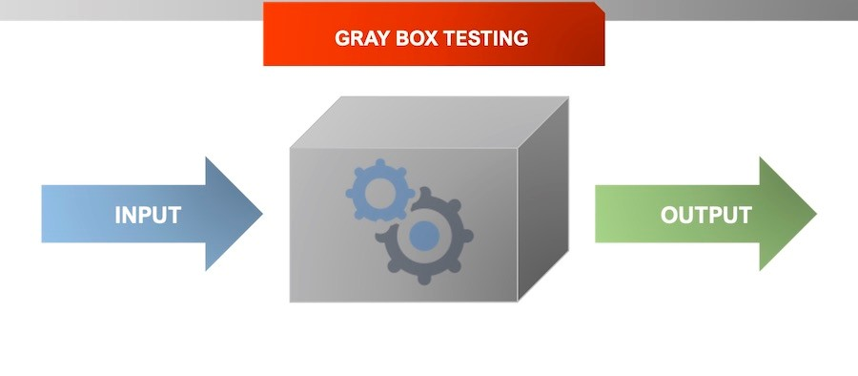

**Figure 4.1.5**

**4.2 Test Case**

**Test Case: - 1 Login**

|  |  |  |  |  |
| --- | --- | --- | --- | --- |
| **Test**  **Case ID** | **Test**  **Description** | **Input** | **Expected**  **Output** | **Stutus** |
| Tc01 | User Login with Valid Credentials | Email : user@example.com, Password : 123456 | Successful Login | Pass/Fail |
| Tc02 | User Login with invalid Credentials | Email: user@example.com, Password: wrongpass | Error Message | Pass/Fail |
| Tc03 | Movie Selection | Select any movie | Selected movie  In detail view | Pass/Fail |
| Tc04 | Payment Gateway  Integration | Valid Card Details | Payment Successful | Pass/Fail |
| Tc05 | Payment Failure  Handling | Invalid Card Details | Payment Failed Message | Pass/Fail |
| Tc07 | Security Testing | Attempt unauthorized access | System prevents unauthorized actions | Pass/Fail |

**Test Case: - 2 Admin**

|  |  |  |  |  |
| --- | --- | --- | --- | --- |
| **Test**  **Case ID** | **Test**  **Description** | **Input** | **Expected**  **Output** | **Stutus** |
| Tc01 | Admin with Valid Credentials | Admin Name : admin  Password: admin | Successful Login | Pass/Fail |
| Tc02 | Admin with invalid Credentials | Username:wronguser  Password: wrong pass | Error Message | Pass/Fail |
| Tc03 | Add movie | Insert Movie Details | Inserted movie  In detail view | Pass/Fail |
| Tc04 | Add movie Null | Insert movie without fillip  Any details | Validation message show | Pass/Fail |
| Tc05 | Delete movie | Click on delete | Movie deleted  successfully | Pass/Fail |
| Tc06 | Logout | Click on logout option | Admin login page open | Pass/Fail |

|  |  |  |  |  |
| --- | --- | --- | --- | --- |
| Test Id | Action | Test Input | Expected Results | Status |
| 14 | Click on booking ticket | Enter datail | Movie ticket Booked Successfully | Pass |
| 15 | Check ticket booking | View admin panel | View details of ticket booked. | Pass |

**Test Case: - 3 Ticket Booking**

**4.3 Implementation Approach**

* System implementation is the process of defining how the information system should be built (i.e., physical system design), ensuring that the information system is operational and used, ensuring that the information system meets quality standard.

The implementation of the movie ticket booking system follows a phased approach:

* **Requirement analysis**: Gather functional and non-functional requirements.
* **Development Phase**: Implement modules such as authentication, movie selection, movie booking, and payment gateway.
* **Testing Phase**: Conduct unit, integration, system, and security testing.
* **Maintenance & Support**: Continuously monitor, debug, and enhance system performance based on user feedback.

**Chapter - 5 Conclusions**

**5.1) Conclusion**

**5.2) Limitation of the system**

**5.3) Future scope of system**

**5.4) Bibliography**

**5.1 Conclusion**

The **cinema ticket booking system** provides a user-friendly platform for reserving movie tickets online. The system enhances convenience by allowing users to book tickets from anywhere. With features like real-time Movie selection, secure online payments, and instant booking confirmation, it ensures a seamless movie-watching experience. The PHP-based implementation offers flexibility, ease of maintenance, and scalability, making it an ideal solution for cinema owners and customers alike

**5.2 Limitation of System**

Despite its advantages, the system has a few limitations:

* **Internet Dependency:** The system requires an internet connection for booking and payment processing.
* **Limited Payment Gateways:** Only a few payment methods may be integrated, limiting customer choices.
* **Security Concerns:** Although encryption is implemented, potential cyber threats remain a challenge.
* **Scalability Issues:** A basic PHP setup may not handle high traffic efficiently without optimization.

**5.3 Future Scope of System**

* **Future Scop of System**
* **AI-Based Movie Recommendations:** Personalized movie suggestions based on user preferences and watch history.
* **Multi-Theater Integration:** Allowing users to book tickets for multiple cinema chains within a single platform.
* **Progressive Web App (PWA):** Making the system accessible as a mobile-friendly application.
* **Blockchain-Based Ticketing:** Enhancing security and reducing fraud in ticket sales.
* **QR Code Ticketing:** Enabling users to scan and enter theaters without printed tickets.

**5.4 Bibliography**

* Bibliography means take reference to prepare any project. Here I concern the website takes reference is as under.
* **Books:**
* **Sommerville, I.** *Software Engineering*
* **Rasmus Lerdorf & Kevin Tatroe.** *Programming PHP*
* **Robin Nixon.** *Learning PHP, MySQL & JavaScript*
* **Website:**
* **PHP Official Documentation:** [**https://www.php.net/docs.php**](https://www.php.net/docs.php)
* **MySQL Official Documentation:** [**https://dev.mysql.com/doc/**](https://dev.mysql.com/doc/)
* **W3Schools PHP Tutorial:** [**https://www.w3schools.com/php/**](https://www.w3schools.com/php/)
* **Bootstrap for UI Design:** [**https://getbootstrap.com/**](https://getbootstrap.com/)
* **Software & Tools :**
* **Php**
* **MySQL Database**
* **Apache Server (XAMPP/WAMP)**
* **HTML, CSS, JavaScript, jQuery for frontend**
* **AJAX for real-time data updates**